**Practical No-6**

**Table**:-

create table CompDep(

Roll int,

Name varchar(20)

);

-----------------------------------------

insert into CompDep values(11,'Sanket');

insert into CompDep values(12,'aniket');

insert into CompDep values(13,'omkar');

insert into CompDep values(14,'mayur');

insert into CompDep values(15,'sushant');

------------------------------------

select * from CompDep;

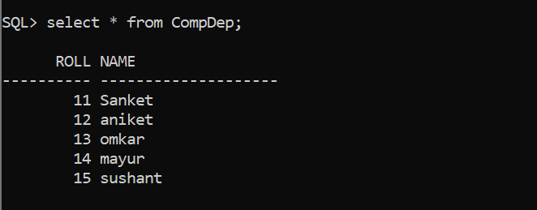

**Table-**

create table Student(

Roll int,

Name varchar(20)

);

------------------------------

insert into Student values(101,'abhi');

insert into Student values(11,'aditya');

insert into Student values(11,'Sanket');

insert into Student values(111,'mayur');

insert into Student values(112,'kunal');

-------------------------------------

select * from Student;

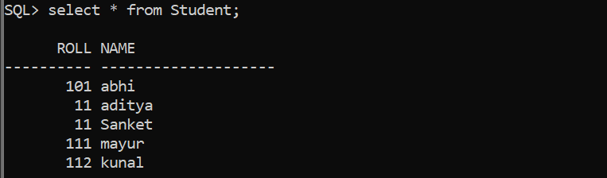

------------------------------------------

set serveroutput on;

**Cursor:-**

declare

cursor cu1 is select Roll,Name from Student;

cursor cu2 is select Roll from CompDep;

rno int;

nm varchar(20);

rno2 int;

begin

open cu1;

open cu2;

loop

fetch cu1 into rno,nm;

fetch cu2 into rno2;

exit when cu1%found = false;

if rno2!=rno then

insert into CompDep values(rno,nm);

end if;

end loop;

close cu1;

close cu2;

end;

/

------------------------------------------

select * from Student;

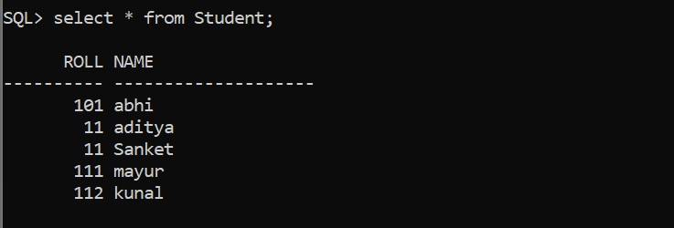

-------------------------

select * from CompDep;



